2015-2016 1st Grade Range Long Range Plans—Page 1
Date | First 30 Days | Lesson
Week 1 | 1-2 | Whole Group Instruction & Good Listening Habits
 | 3-4 | Concepts and Rules of Reading Workshop
 | 5-7 | Turn and Talk, Sharing What & How, Responses & Questions
 | 8, 12 | Just Right Books, Abandoning Books (Allow practice)
 | 9-10 | Taking Care of Books, Classroom Library
Week 2 | 11 | Book Talks
 | 13-14 | Intro. to Response Journals, Using Response Journals
 | 15 | Turn & Talk, Write in Journals, Share
 | 17 | Intro. to Characteristics of Fiction & Non Fiction
 | 18-20 | Literary Elements: Characters, Setting, Problem, Solution
Week 3 | 21 | Review of Literary Elements
 | 22-24 | Non Fiction Text Features
 | 25 | Review of Non Fiction Text Features
 | 26-29 | Habits of Good Readers
 | 30 | Review of What Good Readers Do

2015-2016 1st Grade Range Long Range Plans—Page 2
Date | Thinking Strategy Focus | Benchmark Lesson | Standards | Resources
Week 4 | Model: Ask Questions/  Identify Main Idea and Supporting Details | Unit 1, Week 1 | L.1.2, RI.1.1, RI.1.7, W.1.7, SL.1.1a, SL.1.1b, SL.1.1c, SL.1.2, | 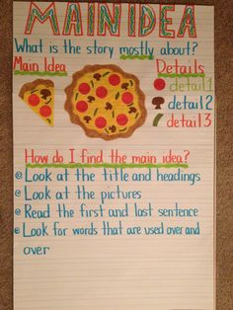
 |  |  |  | Asking Questions Thinking Stems Anchor Chart—page 64; Use this chart for Launching Sequence activity (page 63)
 |  |  |  | Q: 24/7 lesson—The Q Food (page 66-67)
 |  |  |  | Use wordless book (Tuesday) to practice Questioning

2015-2016 1st Grade Range Long Range Plans—Page 3
Date | Thinking Strategy Focus | Benchmark Lesson | Resources
Week 5 | Apply: Ask Questions/  Identify Main Idea and Supporting Details | Unit 1, Week 2 | Intro: Play tropical Rain Forest music to complete sensory chart for Rain Forest (BLM 1)  Savanah Habitat:  https://www.youtube.com/watch?v=rPzSg906ykE  (National Geographic Clip)  Arctic Habitat:  https://www.youtube.com/watch?v=749mFttlSuE  Tropical Rain Forest:  https://www.youtube.com/watch?v=ojTS22t9bbY  Coral Reef:  https://www.youtube.com/watch?v=vcgLc3llEaE
Week 6 | Integrate: Ask Questions/  Identify Main Idea and Supporting Details | Unit 1, Week 3 | Reader’s Theater: Old McDonald’s Noisy Farm

2015-2016 1st Grade Range Long Range Plans—Page 4
Date | Thinking Strategy Focus | Benchmark Lesson | Resources
Week 7 | Model: Visualize/ Analyze Character | Unit 2, Week 1 | Intro: Cotton Balls; Mystery Bag—page 94  Visualizing Thinking Stems Anchor Chart—page 95
 |  |  | 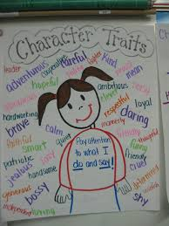
 |  |  | Develop a Class Character

2015-2016 1st Grade Range Long Range Plans—Page 5
Week 8 | Apply: Visualize/ Analyze Character | Unit 2, Week 2 | Story Elements
 |  |  | 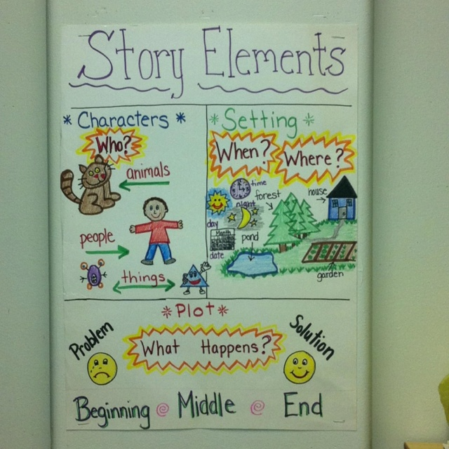
 |  |  | Story Elements Graphic Organizer for Journal

2015-2016 1st Grade Range Long Range Plans—Page 5
Week 9 | Integrate: Visualize/ Analyze Character | Unit 2, Week 3 | Reader’s Theater: The Three Billy Goats Gruff
Week 10* | Model: Determine Text Importance/ Identify Sequence of Events | Unit 3, Week 1 | *Incorporate Explanatory Writing (“How to”)
 |  |  | What’s Important for a Sleepover: Pack an overnight bag with different items; students determine what is important and what is not graphic organizer
 |  |  | Spaghetti: Noodles are the words, Water is the extra
 |  |  | Journal: Sequence Pre-Write with Sequence of Event BLM4
 |  |  | 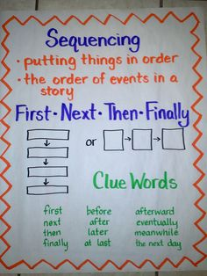
2015-2016 1st Grade Range Long Range Plans—Page 6
Week 11 | Apply: Determine Text Importance/ Identify Sequence of Events | Unit 3, Week 2 | Butterfly Life Cycle
Week 12 | Integrate:  Determine Text Importance/ Identify Sequence of Events | Unit 3, Week 3 | Big Book: Baa Baa Black Sheep Sells Her Wool

2015-2016 1st Grade Range Long Range Plans—Page 7
Week 13 | Model: Summarizing and Synthesize/ Analyze Story Elements | Unit 4, Week 1 | 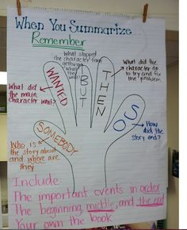  Gardening Gloves for Work Station
 |  |  | 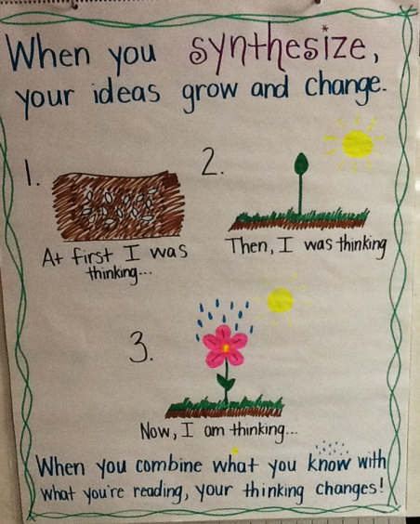 Nesting Dolls Activity—page 104
 |  |  | Synthesizing Thinking Stems Anchor Chart: page 106
2015-2016 1st Grade Range Long Range Plans—Page 8
Week 14 | Apply: Summarizing and Synthesize/ Analyze Story Elements | Unit 4, Week 2 | 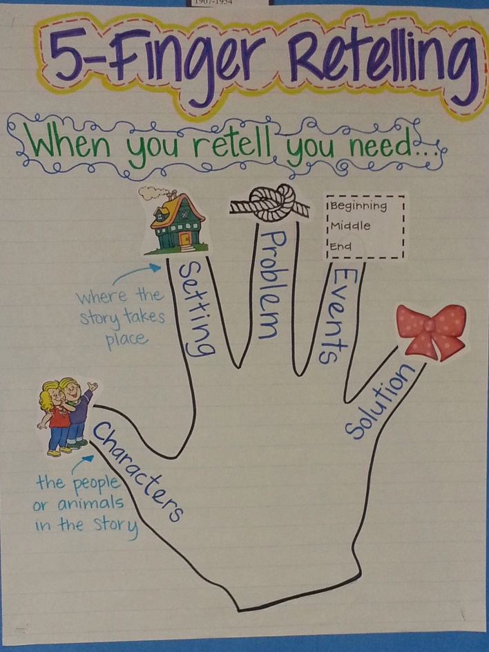
 |  |  | Journals: Retelling Graphic Organizer
 |  |  | Retelling Wheel/Flip Book: Little Red Hen

2015-2016 1st Grade Range Long Range Plans—Page 10
Week 15 | Integrate: Summarizing and Synthesize/ Analyze Story Elements | Unit 4, Week 3 | Readers Theater: Looking for the Muffin Man
Week 14 | Model:  Make Connections/ Make Inferences | Unit 5, Week 1 | Bring in different size clothes; students infer who wears the clothes
 |  |  | Inferring Thinking Stems: page 51
 |  |  | 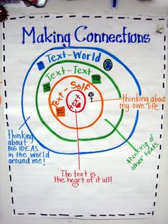

2015-2016 1st Grade Range Long Range Plans—Page 11
Week 15* | Apply: Make Connections/ Make Inferences | Unit 5, Week 2 | *Introduce Personal Narrative  Journal Pre Write: Where I Live (BLM 4)
Week 16 | Integrate:  Make Connections/ Make Inferences | Unit 5, Week 3 | Readers Theater: Humpty Dumpty’s Fall

